Vaccine Prioritization and Optimization (VPOP) Process
Generic Country Concept Note

Executive Summary
In the current finance constraints settings, including reduced Gavi support, national immunization programmes are increasingly required to manage explicit trade-offs between sustaining high-impact vaccines, optimizing delivery of existing antigens, and sequencing future investments within constrained fiscal environments. Addressing these choices in a transparent, evidence-informed, and fiscally responsible manner is essential to safeguarding the substantial health and economic gains achieved through immunization.
Vaccine Prioritization and Optimization (VPOP) provides a structured, country-led decision-support process to address these challenges in the immunization programme. The VPOP process focuses on optimizing the existing vaccine portfolio, assessing the timing and sequencing to introduce newer or underutilized antigens, and aligning vaccine choices with country epidemiological profile, delivery capacity, equity objectives, and affordability. It informs existing national planning and advisory mechanisms and is designed to directly strengthen the National Immunization Strategy (NIS), health sector strategic plan (HSSP), mobilize resources domestically and from donors.
The process is anchored in national institutions. The Ministry of Health provides overall policy stewardship, with technical coordination led by the Expanded Programme on Immunization (EPI) and evidence review and prioritization recommendations led by the National Immunization Technical Advisory Group (NITAG). The Ministry of Finance is engaged throughout to ensure that affordability, sustainability, and medium-term fiscal considerations are fully integrated into decision-making. The process is aligned with Gavi’s holistic planning framework and Alliance investment principles, ensuring coherence between national immunization strategy, partner support, and financing pathways. UNICEF and WHO provide coordinated technical facilitation and analytical support, as requested and under national leadership, in alignment with Alliance policies, informed by Gavi.
Through a transparent, step-by-step approach, VPOP translates agreed priorities into a sequenced, costed operational roadmap, providing a credible basis for dialogue among national stakeholders and partners. This enables coherent alignment of strategy, budgets, and implementation, and supports sustainable immunization planning during periods of transition and fiscal constraint.

1. Background and Rationale
National immunization programmes operate in an increasingly complex decision-making environment, characterized by a growing number of vaccine products, expanding delivery strategies across the life course, and rising expectations for equity, impact and efficiency. At the same time, countries face persistent constraints related to financing, health workforce capacity, cold chain infrastructure and competing health priorities, requiring more deliberate and forward-looking portfolio decisions.
In March 2025, SAGE urged countries to actively involve their NITAGs in guiding decisions on new vaccine introductions and optimizing immunization schedules. These recommendations should be developed through a systematic, country-led process, aligned with national immunization and health strategies, and regularly updated to reflect changing epidemiological trends, programmatic needs, and available resources.
[Add country background and context on why prioritization and optimization is relevant/important]
Gavi eligible countries: With the rollout of the Gavi 6.0 strategy, countries are increasingly required to adopt holistic, evidence-informed approaches to vaccine portfolio decisions, within the guardrails of the Country Vaccine Budgets. These decisions must balance new vaccine introductions, optimization of existing antigens, delivery strategies, and long-term financial sustainability. Vaccine Prioritization and Optimization (VPOP) has emerged as a core strategic process to support countries in making transparent, data-driven choices that align national immunization priorities with available and projected resources.
UNICEF, WHO and Gavi, in close collaboration with Ministries of Health, NITAGs, and other partners, supports countries to undertake VPOP as part of National Immunization Strategy (NIS) development or review, Gavi holistic applications, and/or reprogramming processes. The approach builds on national planning cycles, strengthens country leadership, and reinforces institutional capacity for evidence-informed decision-making.
A growing number of countries are entering accelerated transition phases from Gavi support, with declining external financing for vaccines and preventive health interventions over the coming years. Preparatory Transition and Accelerated Transition countries in Gavi will need to step up their financing share for vaccines as Gavi’s support will reduce rapidly.
Peer-reviewed health economic models consistently demonstrate that routine immunization generates one of the highest Returns on Investment (ROI) in global health. Modeling of 94 low- and middle-income countries (LMICs) indicates that for every $1 invested in immunization, there is a $20 return based on avoided healthcare costs (cost-of-illness) and a $52 return when accounting for the broader societal value of longer, healthier lives. Economic evidence confirms that the vast majority of these gains—over 98%—stem from averted productivity losses due to premature death and disability.
Furthermore, Cost-of-Illness (COI) analyses indicate that sub-optimal coverage or the discontinuation of high-burden vaccines results in catastrophic long-term economic losses that far outweigh short-term fiscal savings. While newer antigens—particularly those with gender-differentiated health impacts, such as HPV—may require longer time horizons to demonstrate their full benefits, these vaccines illustrate how long-term health gains can translate into intergenerational equity and women’s economic participation by improving outcomes that underpin core gender equity indicators. . This underscores the need for structured, transparent decision-making rather than ad hoc or reactive choices.
Against this backdrop, VPOP provides a structured mechanism for countries to make informed choices on:
(i) sustaining and optimizing high-value existing vaccines;
(ii) assessing the timing and sequencing of newer or underutilized antigens; and
(iii) aligning vaccine choices with delivery capacity, primary health care integration, and medium-term fiscal realities.
By embedding these decisions within national institutions and planning processes, VPOP strengthens the credibility, coherence, and sustainability of immunization strategies during periods of transition and resource constraint.

2. Gavi’s Country Vaccine Budgets
In Gavi 6.0 (2026-2030), Gavi introduces a budget ceiling for vaccines during the strategic period for the first time. Gavi organizes vaccine investments into two categories to maximize impact, equity, and value for money: Guaranteed Programmes and Discretionary Programmes.
- Guaranteed programmes form the non-negotiable foundation of routine immunization. They are prioritized because they deliver the highest health impact per dollar invested (highest value for money), contribute to global public goods (e.g. polio eradication), ensure continuity of protection, and uphold inter-country equity.
  - These include: Pentavalent/Hexavalent, PCV (with catch-up), Rotavirus, Measles-Rubella (with catch-up/follow-up), HPV (with multi-age cohorts), IPV, Routine Yellow Fever (routine immunization only), and Hepatitis B birth dose.
- Discretionary programmes address context-specific disease risks and emerging priorities. They provide flexibility to respond to national and sub-national epidemiology but require careful sequencing due to higher operational and fiscal complexity.
  - These include: Malaria, Yellow Fever campaigns, Japanese Encephalitis (with catch-up), Typhoid (TCV with catch-up), Cholera (OCV campaigns), Meningococcal (Men A/MMCV with catch-up), Rabies, DTP boosters, and RSV.
[Paragraph for country specificities including country vaccine budget ceilings, or programme constraints]
Therefore, Country …… intends to conduct a VPOP exercise aiming to strengthen national leadership by ensuring that immunization choices are guided by priorities and uphold progress toward equity. It also provides a transparent and structured analytical basis that supports policymakers in comparing options and directing resources where they can achieve the greatest impact. Operationally, VPOP offers a predictable and coordinated process for reviewing vaccine investments, helping countries move from ad hoc decisions toward well-sequenced, feasible, and fiscally responsible implementation plans.

3. Objectives
Overall Objective
To support the country in making transparent, evidence-informed, and fiscally sustainable decisions on vaccine prioritization and optimization of their national vaccine portfolio in line with national health priorities and system capacities

Specific Objectives
VPOP is a practical decision-support process that will:
- Protect high-return investments already embedded in the routine programme;
- Clarify trade-offs between optimization (coverage, timeliness, delivery efficiency) and expansion (new antigens);
- Strengthen national analytical and decision-making capacities by enhancing the ability of NITAG, immunization decision makers teams to apply epidemiological, economic, and operational evidence to guide vaccine prioritization and optimization, and establish a transparent and structured decision-making process;
- Provide a transparent and credible basis for dialogue with the Ministry of Finance and partners on affordability and sustainability;
- Reinforce national leadership and policy ownership by ensuring that immunization priorities are country‑driven, aligned with national strategies, and supported by coordinated engagement across institutions and partners.
- Feed directly into the NIS, costed operational planning, health sector strategic planning and the country’s next Gavi holistic application.

Through these objectives, VPOP enables alignment between national health priorities, fiscal realities, and programmatic implementation, ensuring that immunization investments remain impactful, equitable, and sustainable over the medium term.

4. Scope of Work and Key Activities
The VPOP process will follow a phased approach, closely engaging the NITAG, the Expanded Programme on Immunization (EPI), the Ministry of Health and key partners.
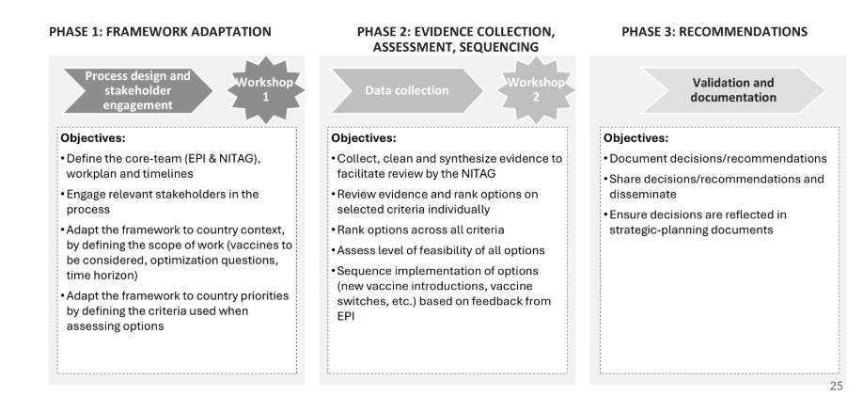
Figure 1 High-level VPOP process description (more details in VPOP 0.1 Introductory module)

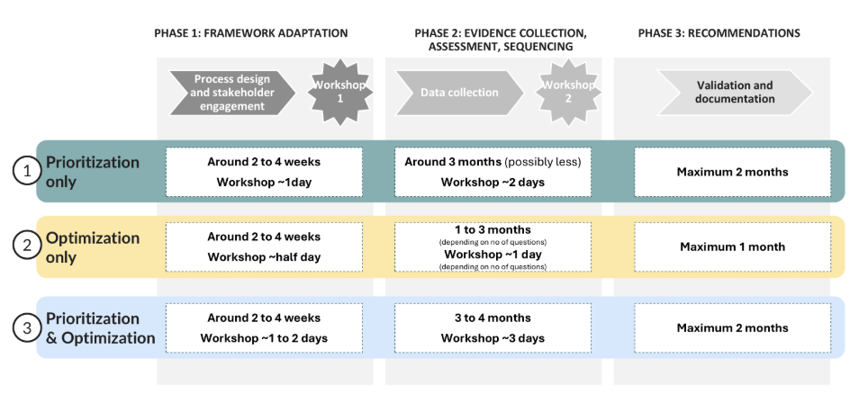
Figure 2 Process configurations
Phase 0: Process Design and Preparation
- Confirm governance, roles, and responsibilities.
- Align the optimization process with ongoing or planned NIS, Health sector strategic plan development or updates.
- Conduct a preliminary review of the current immunization schedule, the vaccine portfolio, the trend of coverage in the country and fiscal space (including procurement cost trends)
Phase 1: Framework Adaptation (Workshop 1)
- Identify and agree on a limited set of priority optimization questions (maximum three) relevant to the country’s current portfolio.
- Define the objectives of each optimization question (e.g. impact on burden of disease, budget implications, coverage improvement, programmatic feasibility).
- Select and weight decision criteria for each optimization question
- Develop a workplan for data collection and evidence synthesis.
Phase 2: Assessment, Optimization, and Sequencing (Workshop 2)
- Collect, consolidate, and synthesize available epidemiological, programmatic, market, cost and financial data.
- Translate evidence into option ranking, for each optimization question.
- Explore programmatic and market constraints (incl. timing) to define the feasibility level of each optimization.
- Develop sequencing recommendations.
- Develop recommendations for selected products/schedule/presentations.
Phase 3: Recommendations and Endorsement
- Document decisions/recommendations.
- Share decisions/recommendations and disseminate.
- Ensure decisions are reflected in strategic-planning documents.

5. Methodological Approach
The VPOP process will be underpinned by Multi-Criteria Decision Analysis (MCDA), combining quantitative and qualitative evidence to support transparent and consistent decision-making. Criteria may include health impact, cost and cost-effectiveness, supply security, cold chain implications, human resource requirements, acceptability, and alignment with national priorities and country’s global and regional engagement.
The framework is designed to be:
- Evidence-based: grounded in the best available data.
- Simple: focusing on a manageable number of key criteria.
- Adaptable: tailored to national context and priorities.
- Iterative: repeatable over time as evidence, markets, and policies evolve.
The full optimization process is expected to be completed over approximately 2–3 months and a combine optimization and prioritization approach will take about 6 months, depending on the availability of experts in the country.

6. Governance, Roles and Responsibilities
The VPOP process will be country-led and anchored within existing national institutions.
Ministry of Health (MoH)
The Ministry of Health will provide overall leadership and policy stewardship of the VPOP process, ensuring alignment with national health priorities and strategic planning processes, including the National Immunization Strategy (NIS).
Expanded Programme on Immunization (EPI)
Expanded Programme on Immunization (EPI) will lead technical coordination of the process, including organizing technical discussions, coordinating stakeholder inputs, and linking VPOP outputs to immunization programme planning and implementation.
National Immunization Technical Advisory Group (NITAG) including its secretariat
NITAG will provide technical oversight and ensure the scientific rigor of the process. It will review evidence, endorse the prioritization and optimization methodology, deliberate on options, and formulate evidence-informed recommendations on vaccine prioritization and sequencing.

UNICEF,WHO and Gavi
UNICEF,WHO and Gavi will provide coordinated technical facilitation and analytical support, as requested, including guidance on methodology, evidence synthesis, and alignment with global norms, under national leadership.
Final recommendations will be validated through existing national decision-making platforms, consistent with national governance arrangements.

7. Expected Outputs
- A consolidated list of priority vaccine optimization questions agreed through the VPOP process.
- Agreed prioritization and optimization scenarios for the country’s vaccine portfolio.
- Clear sequencing of vaccine investments over the medium term.
- Costed operational roadmap linked to the NIS and health sector plan.
- Evidence-informed inputs for the country’s strategic plan such as the NIS and donor applications including Gavi holistic application and budget discussions.
These outputs will support the country in navigating the transition while protecting high-impact immunization investments and responding to emerging disease priorities in a fiscally responsible manner.

Annex 1. Mapping VPOP Outputs to the NIS and Gavi Holistic Application Sections
This annex illustrates how outputs from the Vaccine Prioritization and Optimization (VPOP) process are linked to the NIS and directly inform specific sections of the country’s Gavi holistic application. The mapping is intended to support alignment between national decision-making, the National Immunization Strategy (NIS), and Gavi application requirements, while reducing duplication of effort.

NIS & VPOP Process Step | Key NIS & VPOP Outputs | Purpose | Corresponding Gavi Application Sections
Programme & Financial Situation Review | Summary of immunization performance, equity gaps, delivery bottlenecks, and financing context | Establishes baseline context and key constraints | Information on country cash ceiling and country Vaccine Budgets for Gavi support.  Country context, problem statement, rationale for support
Vaccine Prioritization & Optimization (VPOP)  (NITAG-led) | Prioritized list of vaccines and optimization scenarios with evidence summaries | Justifies investment choices and trade-offs | Strategic priorities: vaccine selection and sequencing
Campaign & Delivery Strategy Considerations | Assessment of routine vs campaign delivery implications and PHC integration | Ensures feasibility and delivery coherence | Implementation approach; delivery strategy
Programme Strategy & Costed Roadmap | Medium-term sequencing of vaccine investments, strategies to deliver vaccines and ZD, surveillance, procurement-supply and logistics, demand and other health systems related aspects with a costed operational roadmap | Links strategy to implementable actions | Workplan, activity sequencing, and costing framework
Budget Impact Analysis & Dialogue | Affordability assessment, funding gaps, and sustainability considerations  Value for money of vaccines choice | Supports dialogue with MoF and partners | Budget narrative; co-financing and sustainability
Consolidation for Application / Reprogramming | Validated priorities and budgets aligned with NIS | Ensures coherence and credibility of the request | Final investment request: justification and annexes

S. Y. Sim et al., “Return on Investment from Immunization against 10 Pathogens in 94 Low- and Middle-Income Countries, 2011–2030”, Health Affairs, vol. 39, No. 8 (2020).
S. Ozawa et al., “Return on Investment from Childhood Immunization in Low- and Middle-Income Countries, 2011–2020”, Health Affairs, vol. 35, No. 2 (2016).
F. Zhou et al., “Health and Economic Benefits of Routine Childhood Immunizations in the Era of the Vaccines for Children Program — United States, 1994–2023”, Morbidity and Mortality Weekly Report, vol. 73 (2024), pp. 682–685.
A. Portnoy et al., “The impact of vaccination on gender equity: conceptual framework and human papillomavirus (HPV) vaccine case study”, International Journal for Equity in Health, vol. 19, No. 1 (2020).
Data collection period can be reduced based on time and resource constraints

